REVIEW OF LOCAL GOVERNMENT INFRASTRUCTURE GRANTS

In collaboration with Sector Departments, municipalities and other stakeholders

Emerging Options for the Reform of the Local Government Infrastructure Grant System
June 2014

This document is to assist stakeholders in providing feedback to the Emerging Options for the Reform of the Local Government Infrastructure Grant System discussion document. The background to the review and full discussion document is available at: http://mfma.treasury.gov.za/Media_Releases/ReviewOfLGInfrastructureGrants/Pages/default_final.aspx.
Stakeholders are invited to submit comments on the different options presented in this discussion paper to working group’s emails by 25 July 2014: grantreview@treasury.gov.za and grantsreview@salga.org.za.

GRANT ADMINISTRATION

Options for Reform
After each section of this document we present a list of “options for reform” as a way of summarising some of the possible changes that could be made to the grant system. Stakeholders are invited to submit comments on their views regarding these options to grantreview@treasury.gov.za and grantsreview@salga.org.za by 25 July 2014.
Options to promote improved planning:
- Include allowance for feasibility, planning and project preparation costs in conditional grant allocations
- Enhance the role of national transferring officers in assessing project plans before funds are transferred
- Introduce incentives to reward municipalities that comply with best practices for planning
- Ensure greater stability and predictability in grant allocations over the three year MTEF period
Options to improve the effectiveness of the reporting system
- Reducing the reporting burden where possible by streamlining reporting, simplifying systems and processes, focusing on outcomes rather than outputs, and consolidating where possible.
- Re-evaluate all reporting requirements with the aim of ensuring fewer / more strategic indicators can give a full picture of grant performance that is useful at the relevant level e.g. policy makers, provincial managers, while reducing the reporting burden where possible
- Strictly enforce reporting requirements on the performance agreements of senior leadership (political and official) of municipalities while reducing the reporting burden where possible
- Enhancing the capacity of national departments to analyse and package data for use by policy makers
- Make performance of local, provincial and national departments open, transparent and accessible to all.
- Use grant data for regular briefings and peer reviews in forums such as Community Meetings Council Meetings, SALGA meetings, portfolio and select committee meetings, MuniMECs and MinMECs, Cabinet meetings
Options to improve national government’s management of the grant system
- National transferring officers should be more proactive in enforcing compliance with grant conditions.
- Indirect grants should be used to build infrastructure projects that municipalities do not have capacity to implement
- A new type of grant could be introduced through which municipalities only receive transfers after work is completed (rather than in terms of a payment schedule)
- New grants should only be introduced if it fits with the infrastructure grant system as a whole; pending that, departments must demonstrate that they have the capacity to administer the grant and provide technical support to municipalities.
- Funding for grant administration should be ring-fenced in the budgets of national departments to prevent it being diverted to fund other priorities
- All grants should be regularly reviewed to assess if: they are meeting their objective, the need still exists, and whether the grant should continue. This should not disrupt stability so windows for change to be limited, i.e. every 3 years?

ALLOCATION MECHANISM
Options for Reform
- Include components within formula grants that account for existing infrastructure
- Update MIG formula sector split with latest data
- Maintain a mix of both formula based allocations (to ensure equity) and project based allocations (for strategic projects) and evaluate the mechanism on a grant by grant basis
- Consider the use of hybrid allocations for some grants; formulas for a basic allocation and project applications to supplement this with more strategic investment
- Where indirect grants are to be applied, establish planning requirements to be met for national transferring departments.

ROLE OF INCENTIVES

Options for Reform
- Use a gradual and differentiated approach to the introduction of incentives. Firstly the system must aim to avoid the perverse incentives listed above with the following reforms:
- Introduce matched-funding (especially for economic-related infrastructure) to avoid grant dependency
- Increased accountability and analysis of data (e.g. unit costs) to avoid reliance on % spend as the main performance indicator, which can lead to inflated costs at the expense of service delivery
- Grants not restricted to ‘new’ infrastructure, to avoid current perverse incentive to persistently build new infrastructure rather than sustainably manage existing infrastructure
- Aim to integrate planning between different spheres and arms of government to avoid grants not being aligned with each other
- Secondly the system can positively incentivise the establishment of capacity, systems and good planning:
- Application and planning processes like those introduced to the health and education grants distributed to provinces
- Accessing funds for renewal conditional on municipalities demonstrating ability to manage and maintain infrastructure e.g. through creating credible asset registers and spending appropriately on maintenance
- Thirdly, once capacity is in place to appropriately respond to incentive systems and data availability on non-financial performance is improved, introduce outcome orientated performance-based grants (this may take several years):
- Establish incentive grant for local municipalities, like the current integrated cities development grant does for metropolitan municipalities, which rewards performance as measured against a set of predetermined and context-specific outcomes (note this is after sufficient capacity building has been completed to ensure municipalities can comply with best-practices)
- Introduce incentive elements into the allocation mechanisms of current grants so good performance – as determined by a range of financial and non-financial indicators – in one year is rewarded with higher allocations in the next year

RENEWAL AND MAINTENANCE

Maintenance
Options for Reform
- Emphasise the monitoring of maintenance funds within municipal budgets – together with the use of tariffs and equitable share funds used to fund maintenance – to provide more information on the need
- Promote full life-cycle costing as a condition in grant frameworks to ensure municipal investment decisions are sustainable ones
- Provide more guidance and funding from national government to improve the systems surrounding the management of maintenance – such as the creation of credible asset registers

Renewal
Options for Reform
- Include windows within existing grants explicitly for the renewal of social (grant-funded) infrastructure
- Update grant formulas to not only allocate for the need of existing infrastructure but also allocate based on the need for renewal of existing ‘social infrastructure’ (that serves the poor)
- Conditionalise funding on the municipality having a credible asset register which they prove they use to prioritise spending
- Renewal funding only for infrastructure that serves the poor and has been properly maintained by the municipality – to avoid perverse incentives

GRANT ARCHITECTURE

Metropolitan municipalities

The following diagram describes this general direction of reform:
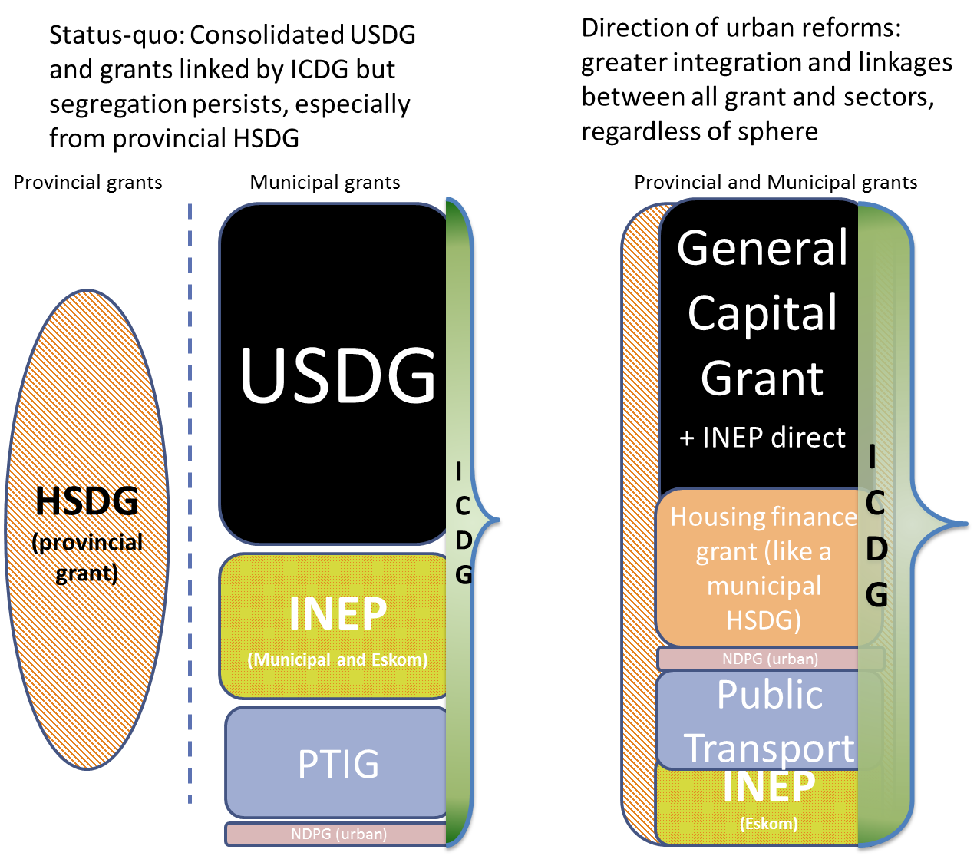
Proposals therefore involve:
Options for Reform
- The integration of the integrated national electrification programme (INEP) grant into a consolidated urban grant package
- Enlarging the ICDG to further incentivise integrated planning of a city’s whole capital budget
- Ensuring the PTIG is more closely aligned to other infrastructure and spatial transformation programmes in municipalities while remaining a specific-purpose capital grant
- Make the PTIG a formula-based general transport grant that could also be integrated in a consolidated urban grant package
- Accreditation of the housing function would mean parts of the human settlements development grant would need to be transferred directly to metropolitan municipalities

Emerging Cities
Options for Reform
- Is there a need for a separate funding mechanism for emerging cities?
- If so, how should this category of municipality be defined and what objective criteria can be used to identify suitable recipients?
- The establishment of a consolidated funding packages – like the former MIG Cities – could help establish an intermediate step between the urban grant packages and the more rural focused grants
- Integrated planning that can unlock growth potential and overcome built environment challenges would be key to such a grant, what else is needed to meet the needs of emerging cities?
- Can the grant system adapt to better support growth investment? Via bulk infrastructure investment for example

Towns and Rural Municipalities

Options for Reform
- Five scenarios are presented in the diagram below
- Option 1: Full consolidation
- Full consolidation of all infrastructure funding into one grant
- Windows would allow space for indirect portions and/or more direct sector involvement in projects of strategic or national importance, otherwise the basic reticulation remains a municipal responsibility funded by a direct grant
- INEP Eskom grant remains separate in each option due to licencing (some municipal areas cannot supply electricity so rely on Eskom)

- Option 2: Majority consolidation (into two basic services and community services grants)
- Two consolidated grants split based on whether the funds are for basic services (water, sanitation, electricity, waste and roads) or more general community services (sports, street lighting, LED etc)
- Taking sports out of the basic services package should allow better and fairer investment choices without the need for ringfencing
- Would see INEP direct and the water grants incorporated into one fund, along with most of MIG
- Would need renewed interaction of the sector departments with the administering department
- Windows would allow space for indirect portions and/or more direct sector involvement in projects of strategic or national importance, otherwise the basic reticulation remains a municipal responsibility funded by a direct grant

- Option 3: Sector grants with a general fund (including roads)
- Join the funding for water and sanitation currently in the MIG with other grants focusing on water and sanitation (RBIG, MWIG, WSOS, RHIG) to create a large sector specific grant
- As before this would be a largely direct grant with windows for potential indirect allocations if projects meet certain criteria (focusing on bulk issues beyond municipal boundaries for example)
- Leave the electricity grant as unchanged with a direct and indirect component
- Create a waste grant from the funds within MIG that is project-based and bulk focused
- The remaining MIG funds (for roads, sports, micro-enterprises and more) will remain in a consolidated fund that allows some municipal discretion over investment choices despite the largely sectoral nature of other grants

- Option 4: Sector grants with a community services grant (excluding roads)
- As above but with roads as a separate stand-alone grant
- Full emphasis on sector grants with only a small community services grant that consolidates funds for more general municipal infrastructure (sports, street lighting)

- Option 5: Full sectoralisation of grants
- As above but with sports and recreation also as a separate stand-alone grant
- Full emphasis on sector grants with little or zero general funds to assist municipalities in investing in municipal priorities

Note the below applies only to the ‘Towns and Rural Municipalities’ category
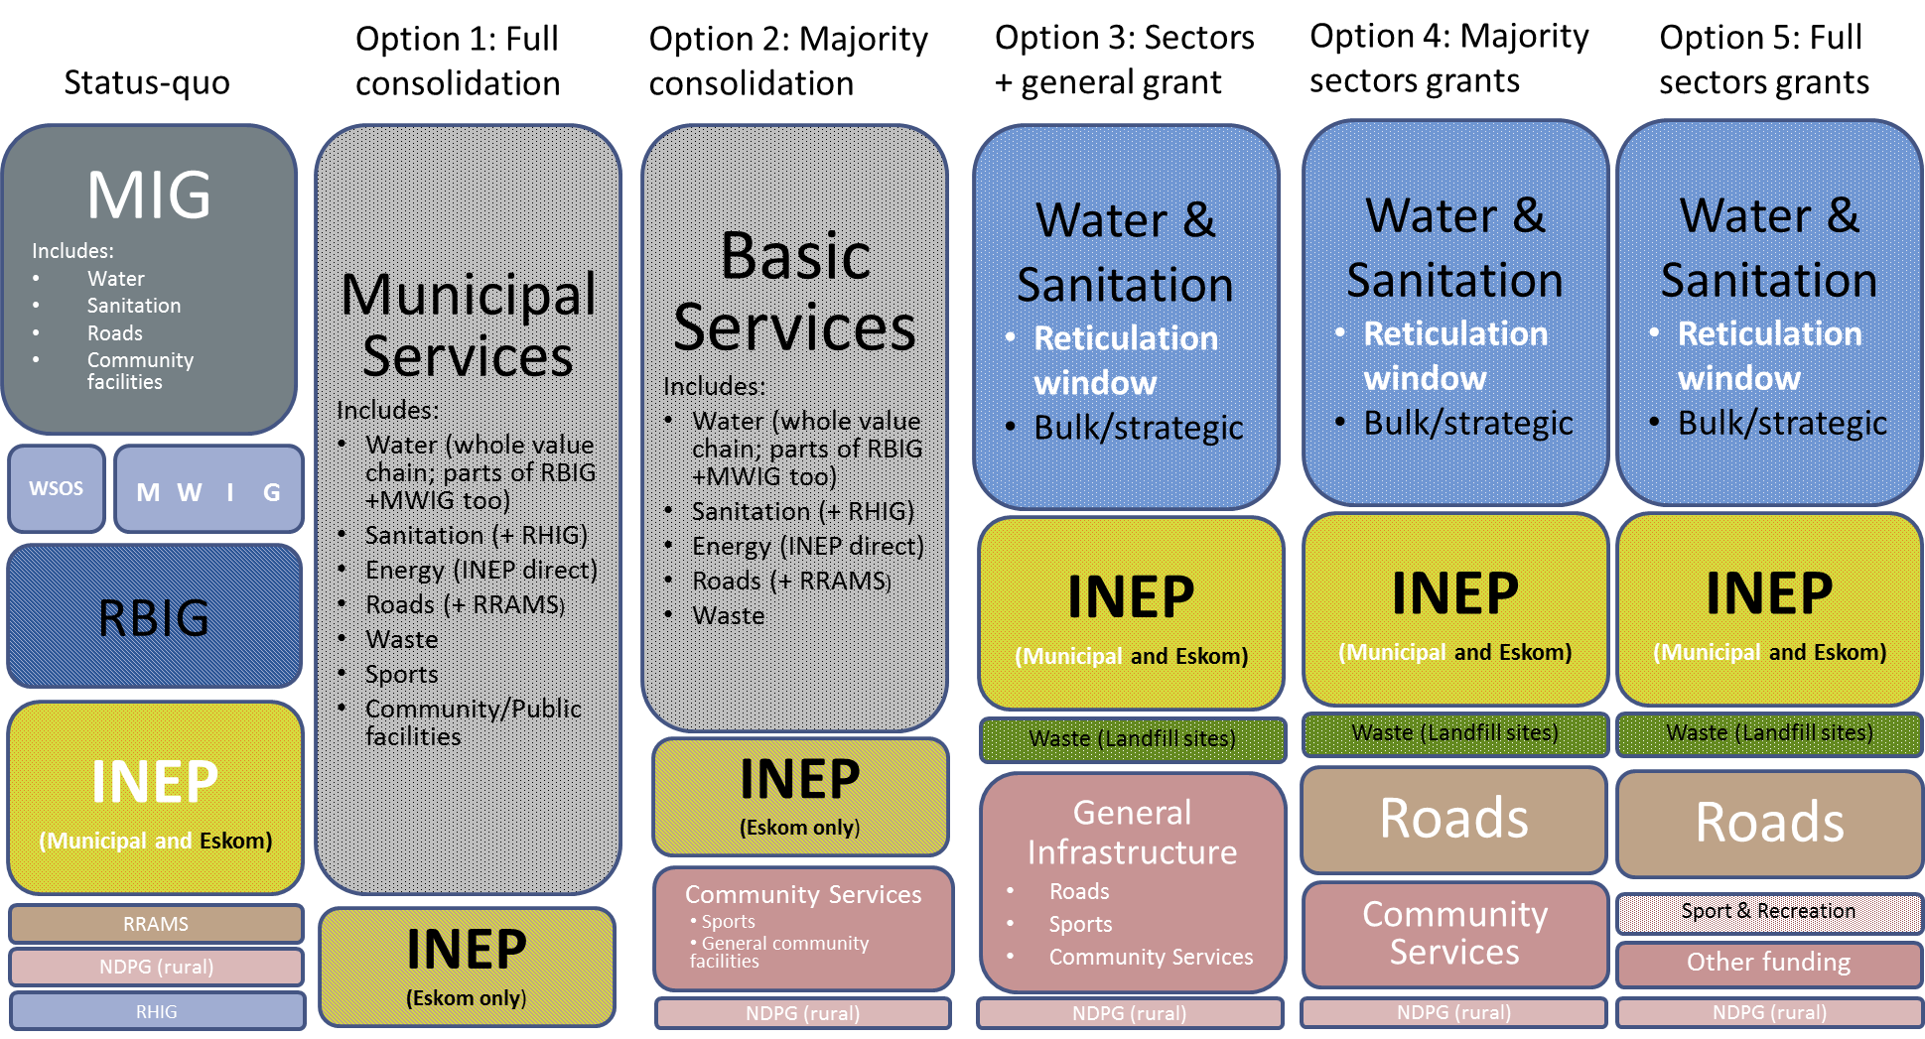
KEY: White text = exclusively direct grant. Black text = direct grant with potential for indirect windows.

