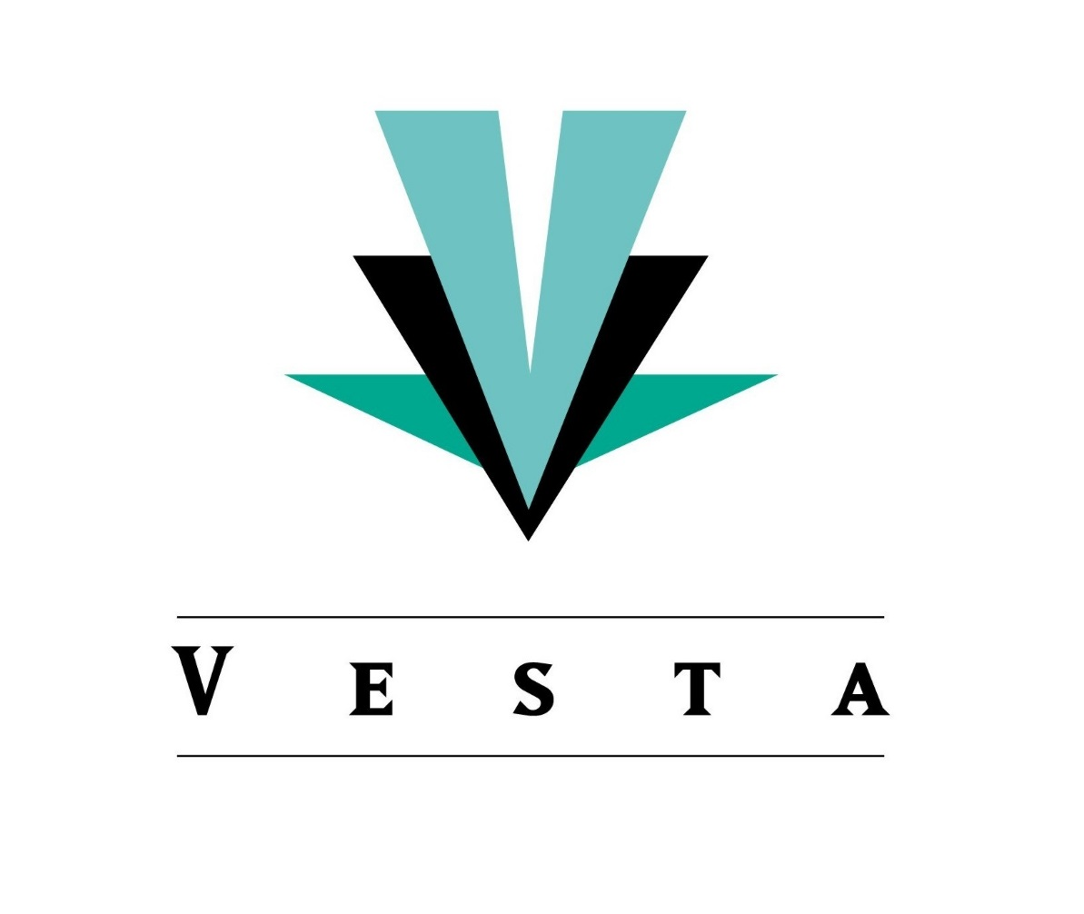

THE SCOA ICF PRESENTATION PAPER
2014-09-18
KEY OBSERVATIONS & FINDINGS
Our understanding of the objectives of SCOA is to:
- Standardize the Chart of Accounts across all spheres of government
- Improve financial reporting and transparency
- Enhance financial management, control & accountability
- Reinforce & enhance accounting standards and best practices
- Rid financial systems of historic bad financial practice
- Simplify the accounting process through a clear and meaningful set of accounts and classification rules
- Decrease the risk of accounting errors by means of strong relational and referential integrity
There are many examples throughout the Item Assets, Liabilities & Net Assets, better known as the Statement of Financial Position, of the same anomaly where Opening & Closing balances are defined as autonomous GL Accounts. For the purpose of this presentation we only need to focus on lines 2695 – 2717, of said chart, because we believe that if the anomaly is resolved for these accounts it will be resolved for all other instances per implication.
  - On line 2702 a single account dealing with “Current Assets: Inventory – Spare Parts” is found which is very much what one would expect to find in the Statement of Financial Position
  - On line 2703 however, there are multiple accounts set up to deal with “Current Assets: Inventory – Water”. What makes this an unexpected and inconsistent departure from the previous line is that there is a breakdown of accounts, let’s call them “pseudo nominal accounts”, consisting of Opening & Closing balance accounts with other “nominal” type accounts in between which suspiciously resemble elements belonging to the Statement of Financial Performance or the SCOA Item Gains & Losses.
  - Furthermore these accounts do not cater for a specific water reservoir but only for a generic inventory item which gives rise to the obvious question whether this account, “Current Assets: Inventory – Water”, is the control account for a subsidiary inventory dealing with the different water inventories/reservoirs in any event?
  - There is also no allowance made for the sale of water through the Cost of Sales posting which implies that this account will continue to grow as an asset with the only usage accounted for being the losses as detailed in the “pseudo nominal accounts”.
To acquire a conceptual and technical understanding of our problem with the Opening & Closing balance accounts in the Statement of Financial Position, as depicted in SCOA, one has to first agree on three very basic accounting principles and then we have to examine exactly what an Opening and a Closing Balance is.
- Only the Accounts for Assets, Liabilities and Equity (Net Assets) as found in the Statement of Financial Position have Opening and Closing balances because they exist across financial periods. The closing balance of period one becomes the rollover opening balance of period two. Their financial balances are not cleared at the end of a financial period in order to start a new financial period with a zero balance as is found in the nominal accounts relating to the Statement of Financial Performance commonly known as the Income Statement.
- Therefore each and every account in the Statement of Financial Position must have an Opening and a Closing balance.
- The opening & closing balances of a specific GL account cannot affect the financial position of another account. Put another way, real GL accounts are not manipulated and/or convoluted in order to produce a calculated opening or closing balance for another account.
The Opening balance of a General Ledger Account in the Statement of Financial Position is equivalent to the closing balance of the same account from the previous period and is the first entry into that account at the start of a new financial period.
This brings us to the first important disparity between accounting best practice and SCOA which is the fact that an opening balance is only an entry into an account and not an account in its own right.
The Closing balance of a specific account (in this instance Water Inventory) is merely a summation of the net financial value of the account as calculated from the opening balance, debit and credit postings to that specific account (NOT A SET OF ACCOUNTS) within a specific financial period. In a computerized system this closing balance amount will be calculated and displayed real time as transactions are processed. This feature then enables the financial practitioner to analyze and compare a specific GL account e.g. Current Assets: Inventory – Water’s actual stock with theoretical stock in real time.
The second very important disparity between accounting best practice and SCOA is the fact that the Closing Balance of any account, Nominal or Real, is a calculation of net value and not an account in its own right. It is not even an entry into the Chart of Accounts because either way, whether Closing Balance is handled as an account in its own right or an entry into an existing account, it will result in a problem in the trial balance
The accounts in SCOA, which are created between the Opening Balance and Closing Balance accounts, must have their own Opening & Closing balances because of the accounting principle stated upfront. If they are cleared at the end of the financial period, like a nominal account, then they do not comply with this principle and therefore do not belong in the Statement of Financial Position. If, on the other hand, these accounts are not cleared at the end of a financial period their balances will merely grow unchecked and this will again cause problems with double counting in the trial balance.
The third very important disparity between accounting best practice and SCOA is the fact that the accounts between an opening balance and a closing balance conform to the principles of “pseudo nominal ledger accounts” and therefore do not maintain their own opening and closing balances across financial periods.
Based on the accounting principles stated upfront it goes without saying that one GL Account in the Statement of Financial Position cannot, under any circumstances, affect the balances of another account in the same chart. This is however exactly what happens with the accounts between the opening and closing balances accounts. Even worse still, they relate as a whole, to a parent account which has never been posted to directly.
This brings us to the fourth and final disparity between accounting best practice and SCOA in that GL Accounts within the Statement of Financial Position are convoluted in such a way as to directly impact one another.
The main deficiencies and weaknesses of this concept:
- Does not conform to standard accounting practice
- Is not applied consistently across all Accounts
- Prohibits financial month-ends because there is only one opening and one closing balance instead of twelve
- Limitation on what can be posted to any given account (E.g. Cost of Sales in Water Inventory is omitted as a valid account which in turn forces a periodic inventory system)
- Makes for unnecessary complexity and loss of functionality in the chart as well as the Financial System
- Huge risk for erroneous postings because of the disjunction between the contra accounts
  - Instead of a straight forward Debit of Water Inventory and Credit Water Purchases or Accounts Payable for a purchase you leave the accounting official to decide which relevant or irrelevant Water Inventory vote to Debit whilst Crediting Water Purchases. As an example the official can Debit the Opening Balance account and Credit Water Purchases and the overall result will still be the same but the reporting classification will be incorrect.
Recommendation:
- The same reporting classification information sought by National Treasury can be obtained from the contra entries e.g.
  - The contra posting for water purchases will be Purchases
  - The contra posting for a specific water loss will be the SCOA Item Losses account
  - The contra posting for sales will be Cost of Sales
  - In exactly the same way as the following T-Accounts reflect the information

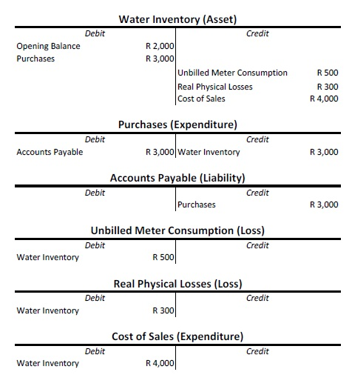

It is clear from the above transactions that all relevant SCOA Reporting information will be available from the contra posting accounts without having to subdivide the Water Inventory account into the “pseudo nominal accounts”.
It is also impossible to make a wrong classification with regard to the postings to Water Inventory as the contra account determines the classification of the posting.

For comparative purposes the T-Accounts for the SCOA configuration is illustrated below:
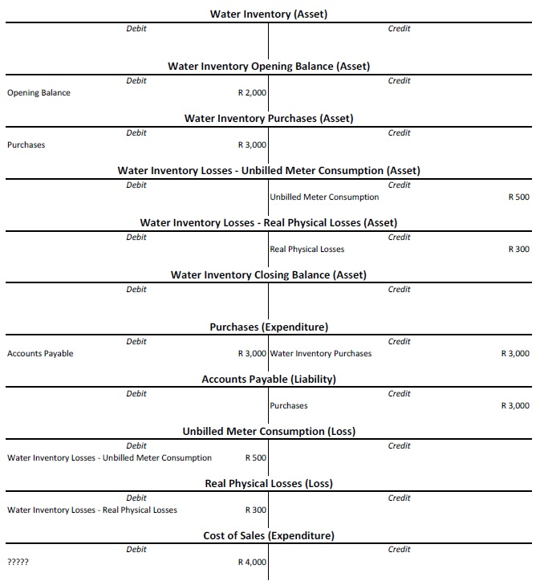

Please Note:
- The absence of a Cost of Sale contra account
- The misnomer of Losses Accounts classified as Assets in the Statement of Financial Position
- The actual Water Inventory Asset that has no direct values in this Configuration
- There are double the number of accounts required to achieve the same result
- It is highly likely that an incorrect call will be made with regard to the classification of the posting to the Water Inventory sub-accounts. E.g. The R 3000 Purchases could very easily have been posted to any of the other accounts creating disparity between the contra account and its classification.

Example of what a GL Account in the Statement of Financial Position should look like with a proper separation of Financial Periods.
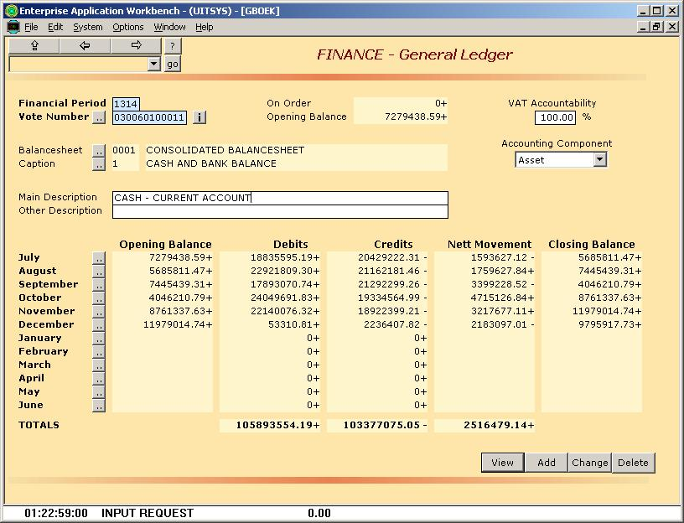
- The Size and Complexity of the SCOA
Other issues which we believe compound the risk of implementing the Chart “As-Is” are:
- In the Item Assets, Net Assets & Liabilities there are numerous examples of the same account being repeated only to be differentiated by its Regional Indicator. Because Region forms part and parcel of the SCOA classification framework the posting transaction should already contain region and it is wholly unnecessary to define it again in the account itself. Examples are:
  - Lines 421-1028 (Capital Transfers & Subsidies to District Municipalities
  - Lines 1155-1263 (Capital Transfers & Subsidies to Provincial Departments)
  - Lines 1727-2334 (Operational Transfers & Subsidies to District Municipalities)
  - Lines 2467-2575 (Operational Transfers & Subsidies to Provincial Departments)
  - Exactly the same happens on the Liabilities side
- The Opening & Closing balance anomaly, discussed earlier, compounds this repetition problem further.
  - Lines 3905-3924 contain examples of this problem.
- The above goes a long way in explaining why there are a massive 21368 General Ledger accounts defined for the Statement of Financial Position.
- Not necessarily an error but definitely a concern is the fact that the breakdown of the 21368 accounts in the Statement of Financial Position are as follows
  - 25% relate to the Balances accounts discussed earlier
  - 28% relate to duplications in the District Municipality domain
  - 5% relate to duplications in the Provincial Departments
  - And “Transfers & Subsidies” make up 13005 of the accounts in the Statement of Financial Position
- The analysis and outcomes from the 2014/15 Benchmark Assessment would confirm that approx. 70% of the estimates of revenue from within the Municipal Fiscal Framework is underpinned by revenue from the Primary Sources i.e. water, electricity, refuse, sanitation and property rates. In addition, the Secondary Sources of Revenue i.e. libraries, cemeteries, traffic fines would constitute approx. 15% of the Municipal Fiscal Framework. This leaves Transfers & Subsidies, which are issued in terms of the Division of Revenue Act, making up the remaining 15%. Bearing in mind that these figures are approximations and that each municipality will have a different ratio it still remains a concern that 92% or 5204 of the Item Revenue Accounts are related to Transfers & Subsidies and only 466 accounts or 8% of the Revenue chart relate to the core functions of the municipality.
- In the Item Revenue there are also numerous examples of the same account being repeated as is the case in the Item Assets, Net Assets & Liabilities. Examples are:
  - Lines 821-1428 (Non-exchange Revenue: Transfers and Subsidies - Capital: Allocations In-kind - District Municipalities)
  - Lines 1546-1654 (Non-exchange Revenue: Transfers and Subsidies - Capital: Allocations In-kind - Provincial Departments)
  - Lines 2117-2724 (Non-exchange Revenue: Transfers and Subsidies - Capital: Monetary Allocations - District Municipalities)
  - Lines 2851-2959 (Non-exchange Revenue: Transfers and Subsidies - Capital: Monetary Allocations - Provincial Departments)
  - Lines 3422-4029 (Non-exchange Revenue: Transfers and Subsidies - Operational: Allocations In-kind - District Municipalities)
  - Lines 4145-4253 (Non-exchange Revenue: Transfers and Subsidies - Operational: Allocations In-kind - Provincial Departments)
  - Lines 4716-5323 (Non-exchange Revenue: Transfers and Subsidies - Operational: Monetary Allocations - District Municipalities)
  - Lines 5452-5560 (Non-exchange Revenue: Transfers and Subsidies - Operational: Monetary Allocations - Provincial Departments)
- Exactly the same phenomena repeats itself in the Item Expenditure with 5176 or 91% of the Expenditure accounts relating to Transfers & Subsidies and only 552 or 9% to the core Operational Expenditure classifications. The repetition of accounts are roughly of the same magnitude as found in the Item Revenue.
We believe that the number of accounts in the Statement of Financial Position and the Statement of Financial Performance can be significantly reduced without any negative impact on the SCOA reporting objectives.
Par 20 of the SCOA Summary document (Aug 2014) clearly states that the development of this framework must give recognition to international standards, guidance and best practices. In this regard we believe that SCOA must diligently align itself with best practice in accounting standards with regard to the concept of GL accounts for Opening & Closing Balances in the Statement of Financial Position.

