LG Upload Portal Registration

# Registration process and rules:

* The web address of the LG Upload portal is [**https://lguploadportal.treasury.gov.za**](https://lguploadportal.treasury.gov.za/)
* National Treasury requires that the Municipal Manager, who is accountable for the data and supporting documents of a municipality, to register on the portal for the upload of these information.

The Municipal Manager may find it necessary to delegate the upload task. The Municipal Manager remains accountable for the content of the submitted data strings and supporting documents to the LG Upload portal, by the delegated municipal official. The delegation should be formally done in writing, declaring the Municipal Managers’ consent of the delegated official(s) – Name, Surname and e-mail address, to perform the upload of all the required data files and supporting documents to the LG Upload Portal.

Most importantly, note that only permanent officials may be granted authority to perform submissions to the LG Upload portal. The formal delegation memorandum must be signed by the Municipal Manager and e-mailed to [cornell.botha@treasury.gov.za](mailto:cornell.botha@treasury.gov.za) for verification of the delegated official(s) registration and contact details on the Local Government database.

Both the Accounting Officer and the delegated official(s), must be registered on the Local Government database in order to be approved for upload registration on the LG Upload Portal. Divergence between the contact details will result in delayed registration approval of the official(s) on the LG Upload portal. Should this be the case, National Treasury will e-mail the ‘contacts information document’ to the registration applicant and the Municipal Manager to amend and/or add the contacts details with the most recent and correct contacts information. The updated document should be e-mailed without delay, to the address indicated on the Contact Information spreadsheet. The Local Government database and LG Upload portal will be updated accordingly. Registration may then proceed. (To view an example of this well-known Contact Information document, which is sent quarterly to municipalities for update, refer to Contact Info)

* To register, click on the URL [**https://lguploadportal.treasury.gov.za**](https://lguploadportal.treasury.gov.za/)or sign on to the National Treasury website and follow the path.

The user will need to press the register button only, as shown below:

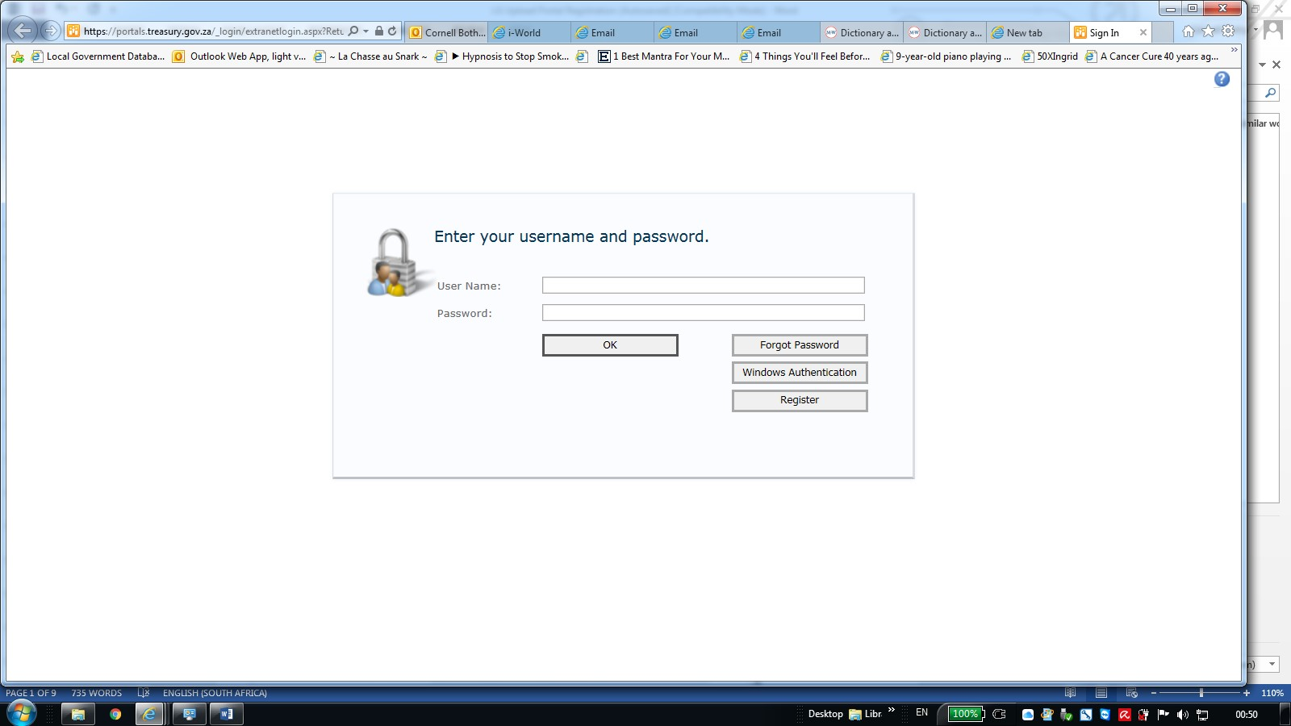

* The following screen will be displayed and the user has to complete all the required **\*** information:

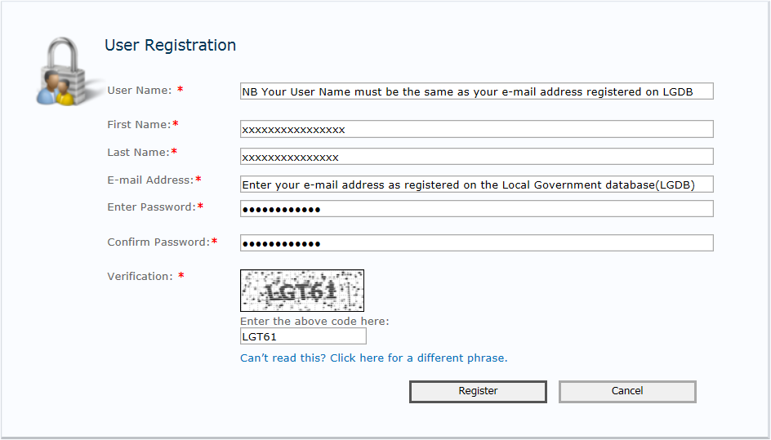

e.g. Upload@9

* It is of utmost importance that the official enters his/her e-mail address in the ‘User Name’* field, **to avoid rejection of the portal registration (**see screenshot below) This ‘User Name’ must be the same as the e-mail address that is entered in the ’E-mail address’* field**.** If these values are not the same, National Treasury will reject the registration and inform the registering municipal official by e-mail. The official will have to re-register according to this requirement.
* Adhering to the above as well as consistency between the portal registration information and the contacts information on the LGDB, are equally important for the upload portal registration to be approved.

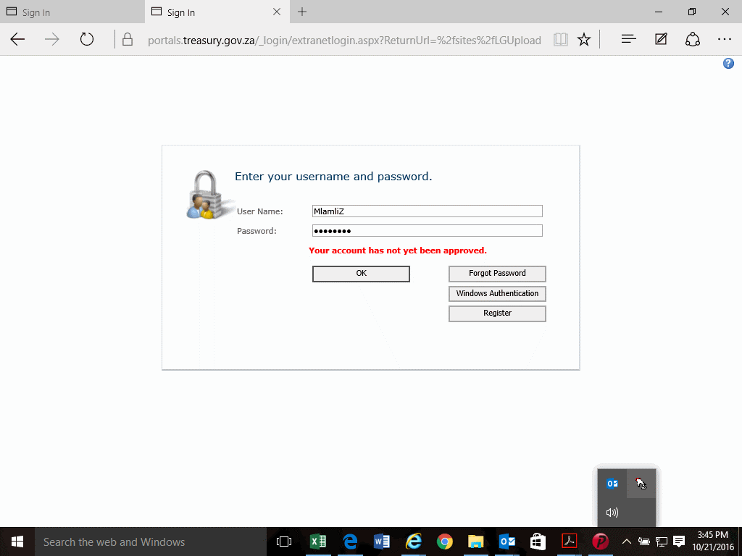

* The *password* must have at least seven (7) characters of which at least one (1) character must be a non-alphanumeric character, i.e. special characters, e.g. “@, #, $, %, ^, &, * ” etc. If the entered password does not satisfy this criteria, error message: ‘The password must contain at least 1 non alphanumeric character’.
* Press the Register button to submit the completed registration application to the administrator at National Treasury.

# Approval of registration by NT Portal Administrator

## After the Upload portal administrator approved the registration and upload rights to the portal, the user will receive an e-mail to confirm the successful registration:

## 

* Upon receiving confirmation of the upload registration approval of the municipal official(s), the delegation letter must be uploaded if the Municipal Manager delegated the submission of information to municipal officials.
* The user can now sign in to the portal to upload information:

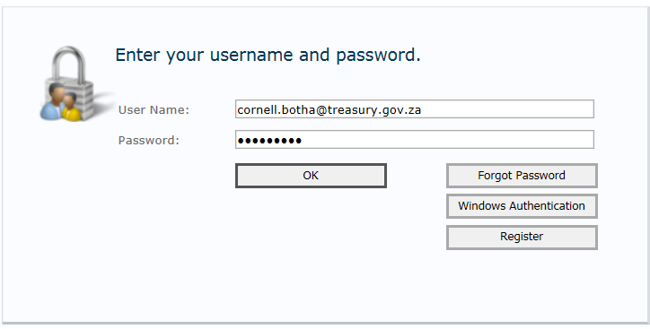

* The portal may also be accessed from the National Treasury website <http://www.treasury.gov.za>

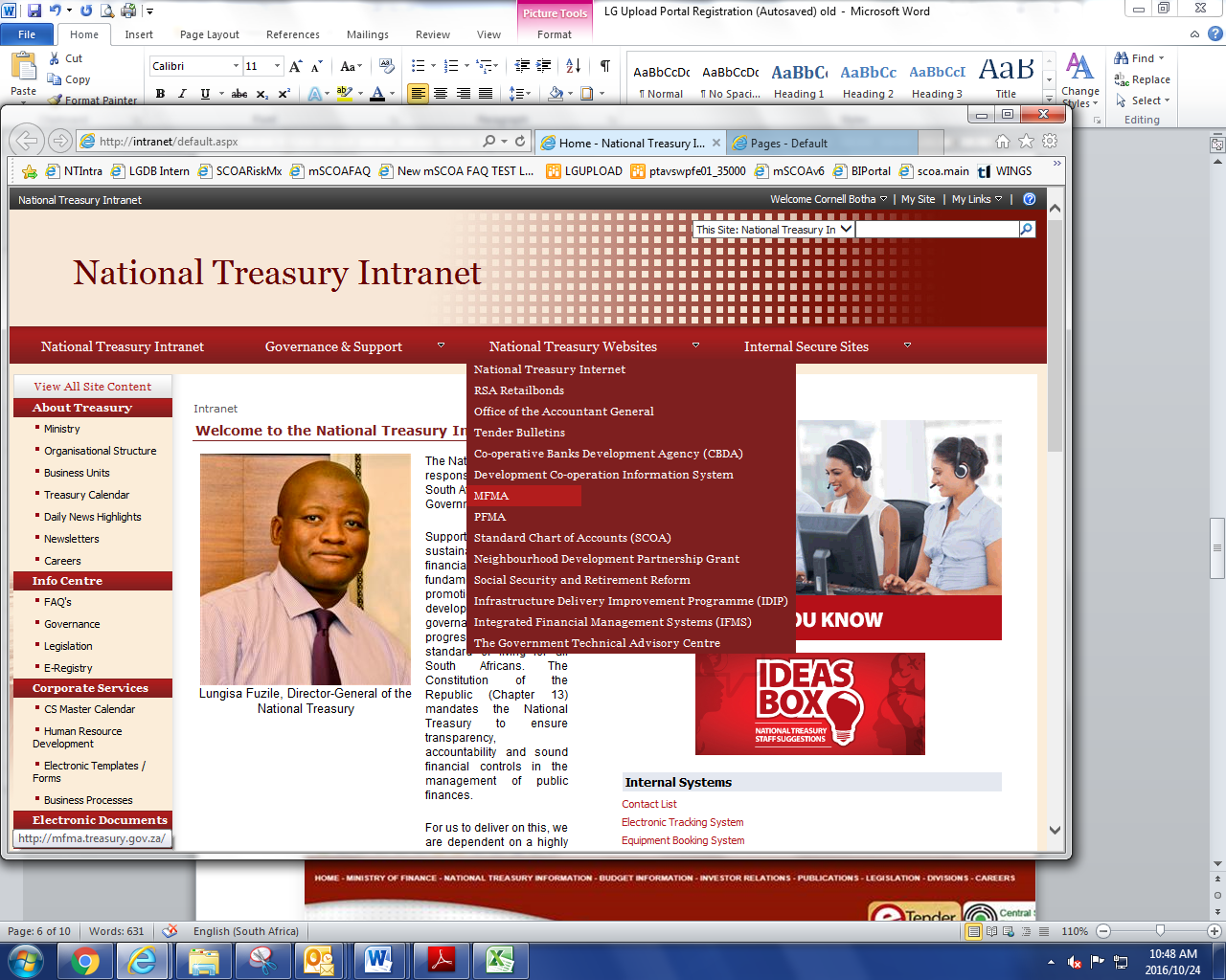

[**MFMA**](http://mfma.treasury.gov.za/Pages/Default.aspx) **>** [**Regulations and Gazettes**](http://mfma.treasury.gov.za/RegulationsandGazettes/Pages/default.aspx) **>** Municipal Regulations On A Standard Chart Of Accounts > 06. Local Government Upload Portal

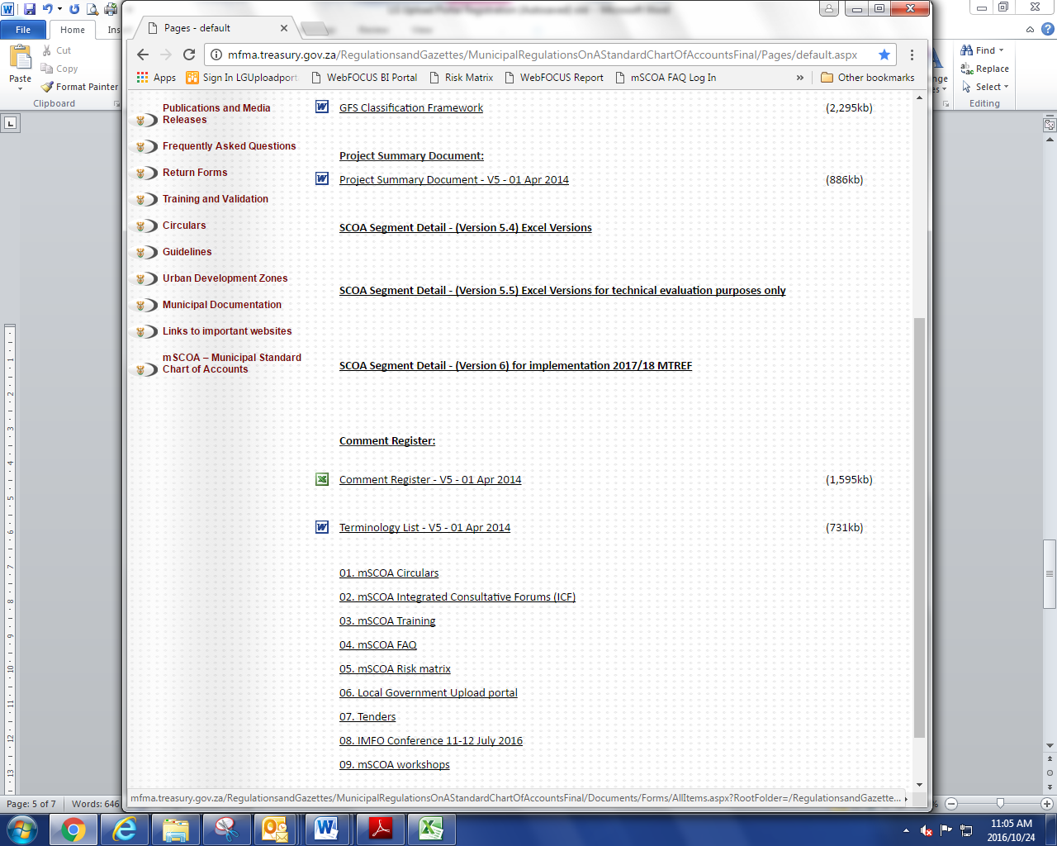

# Municipal Contact Information

Please do not use this example to update information as it is not in the required Excel format.

